AM310 – Instrumentation and Theory of Experiments

Drag Coefficient of a Sphere:
Variation with Reynolds Number in Subsonic Flow

CONCEPTS: Flow separation, laminar/turbulent boundary layers,
drag force, pitot-static tube, load cell, pressure transducer, roughness, interference, calibration, hysteresis, wind tunnel operation.

- Introduction

The characteristics of fluid flow past a rounded solid body can undergo significant variation when the flow character in the boundary layer on the body changes from laminar to turbulent. The flow past a sphere is a prominent example of this phenomenon. It is found that the drag coefficient of a smooth sphere decreases considerably as the Reynolds number (based on diameter) is increased above about 3 x 10⁵, the value at which the boundary layer on the sphere undergoes transition from laminar to turbulent flow. This transition Reynolds number can be lower if the surface of the sphere is roughened. This experiment examines the variation of the drag coefficient of spheres with different levels of roughness for different Reynolds numbers in the vicinity of this critical value.

- Theory

The drag on a sphere is composed of viscous drag and pressure (or form) drag. Viscous drag is the effect of fluid friction on the surface of the sphere. Pressure drag occurs because of the distribution of pressure on the sphere. In flow situations corresponding to very low Reynolds numbers, the pressure distribution is symmetric front to back on the sphere and there is no pressure drag. At higher Reynolds numbers, the pressure on the downstream half of the sphere is lower than that on the upstream half and there is a net force on the sphere in the same direction as the velocity. The difference in pressure comes about because of flow separation. When the boundary layer on the sphere is laminar, separation occurs near the equator (i.e., the circle of maximum diameter on the sphere with plane perpendicular to the flow) and there is a large separation region with low pressure downstream of the sphere. However, when the boundary layer becomes turbulent, the fluid elements near the surface have more energy because of better mixing and hence stay attached to the surface beyond the circle of maximum diameter. The separation region is smaller and thus the pressure drag is lower. When the boundary layer character is changed from laminar to turbulent, there is a sudden decrease in the drag coefficient of the sphere. (See Figures 1 through 5 below). [POINTS TO PONDER- Is the laminar to turbulent transition we are talking about here occurring in the approach flow or in the boundary layer on the sphere? What is the Reynolds number of the approaching flow based on the tunnel test section height? Does the flow in the tunnel change from laminar to turbulent during the experiment?]

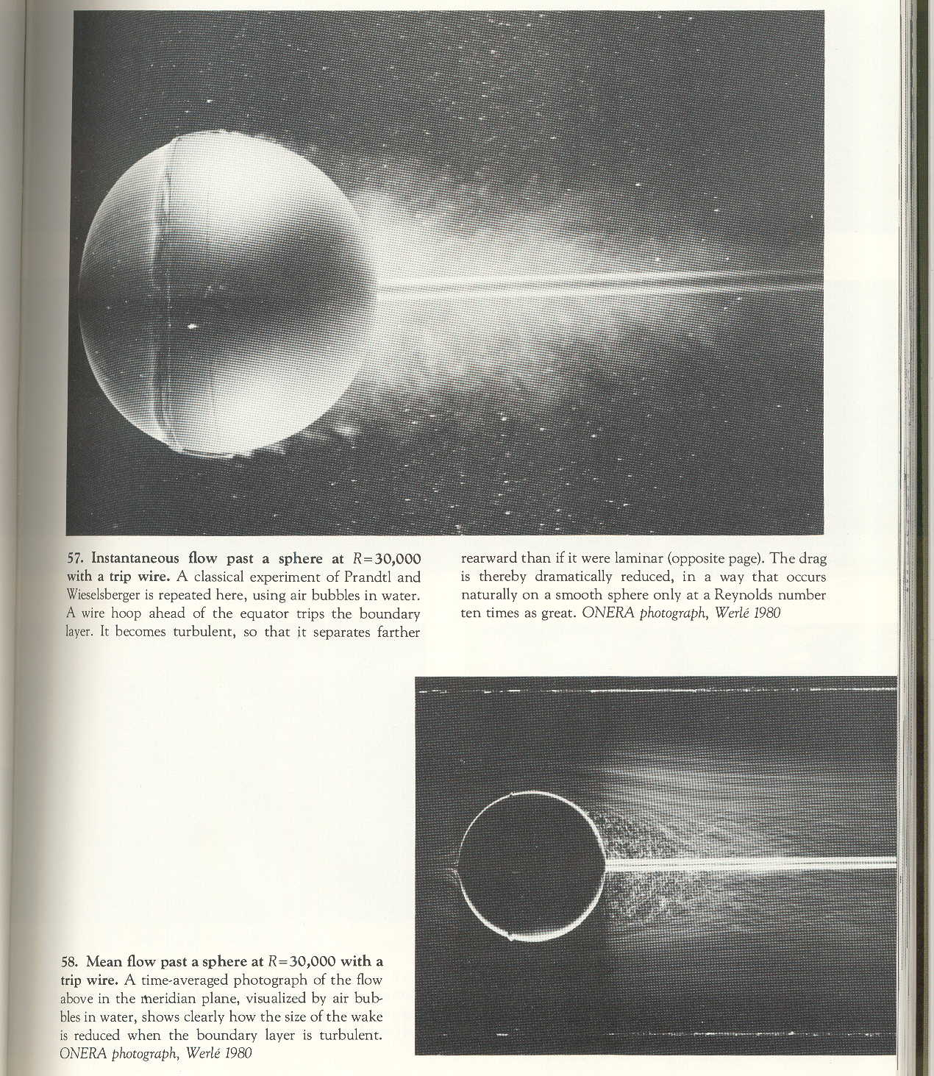
Figure 1: Flow visualized around a sphere with a trip wire

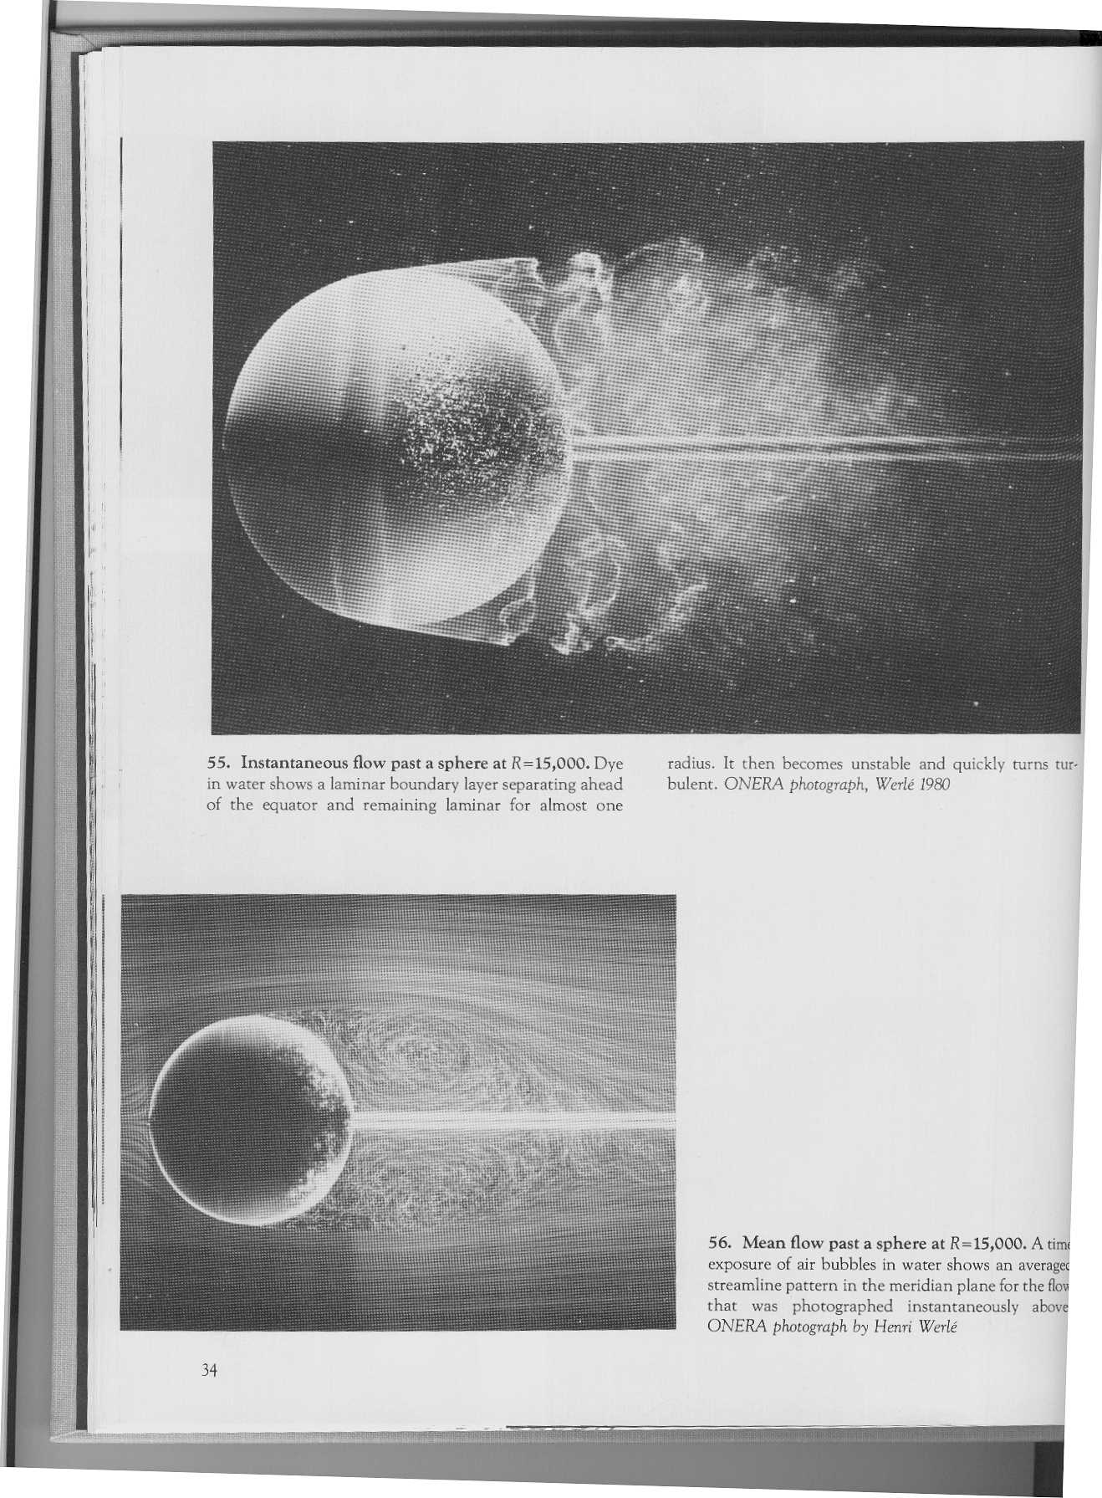
Figure 2: Flow past a sphere; the top figure shows the instantaneous field, while the bottom shows the time-averaged field.

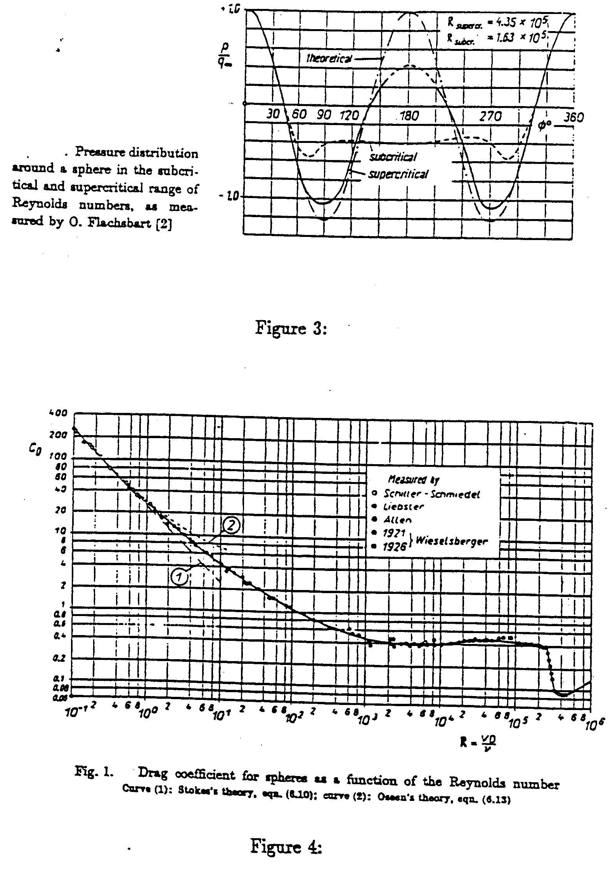

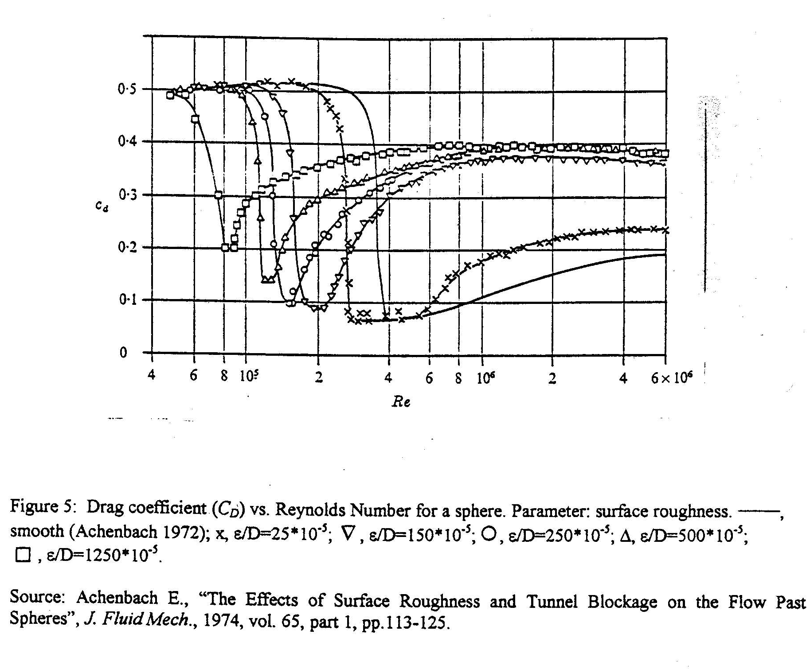
The pressure drag force (D) actually depends on four physical parameters of the flow: The diameter of the sphere (d), the flow velocity (U), and the fluid's density (ρ) and viscosity (μ). Determining how the pressure drag changes with changes in all of these parameters would involve a great many expensive tests (e.g. we would have to use different model spheres to vary the diameter and different fluids to vary the density without changing its viscosity, and it might be impossible to find fluids with different densities but the same viscosity). However, the powerful analytical tool called dimensional analysis tells us that if we consider a dimensionless pressure-drag coefficient (C_{D}) instead of the pressure drag itself, this coefficient can be shown for a smooth sphere to be a function of only one single dimensionless parameter, namely the Reynolds number, Re (which is a combination of the four parameters mentioned above). For a roughened sphere the dimensionless roughness, ε/d also affects C_{D}.

D = funct(d,U,ρ,μ,ε ) (1)

but it can be shown by dimensional analysis (DO SO IN YOUR PRELAB) that

C_{D} = funct (Re) (2)

in which

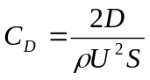 (3)

where S is the frontal area of the sphere (πd²/4), and

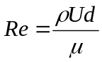 (4)

Dimensional analysis itself, however, cannot tell us how the drag coefficient changes with changes in the Reynolds number. This functional relationship must be found from known physical laws or from experiment. In this lab you will be determining the functional relationship from the experiment. Dimensional analysis lets you determine the complete functional relationship between the drag coefficient of a sphere with a fixed ε /d and the Reynolds number by varying only one parameter in your experiment (the velocity, which is easy to vary) instead of all four parameters.

- Experiment

The experiment consists of placing a sphere in a uniform airflow and measuring the velocity of the flow and the drag force on the sphere at various airspeeds. The Reynolds number and the drag coefficient can be computed from the data.

The uniform airflow is created in a low-speed wind tunnel (see Figure 6). The model sphere is mounted in the test-section where the air velocity can be varied between about 5m/s and 50m/s. [Note, the test section interior dimensions are: Length 48”, width 18”, height 18”]. The velocity of the flow is measured by means of a pitot static probe placed in the tunnel above the sphere (see Figure 7). The difference between the static and total pressures coming from the probe is measured with an inclined tube manometer and a pressure transducer, with the voltage output from the pressure transducer being sent to a PC.

The wind tunnel system is an Eiffel type suction tunnel. Air is drawn into the radiused inlet, through a honeycomb and screen pack and is accelerated through the contraction into the test section. The system air regains static pressure through the downstream diffuser. Flow continues through the axial fan and acoustic diffuser and is discharged to the atmosphere. An in-line centrifugal type fan is used to control the tunnel. The fan is driven by a 25Hp variable speed AC induction motor. A transistor invertor type variable frequency controller regulates fan shaft RPM. A speed control station, located at the upstream end of the diffuser, regulates the test section velocity. The invertor may be controlled using either the keypad or a 0-10VDC input. For this experiment the 0-10VDC input is provided through the BNC-2090 box and controlled by the PC.

Note: The tunnel can be stopped in an emergency by switching off the power at the speed control station!

Flow Conditioners
Test Section
Tunnel Speed Indicator (Keypad)
Fan
Acoustic
Diffuser
Mount
Diffuser
Power Control Station
Figure 6: Low-speed wind tunnel

The drag force on the sphere is measured by means of load cells on the wind tunnel mount (see Figures 8 and 9). The load cells are mounted within the arm of the mount and measure the forces applied to the mount arm by the sphere. The load cells are transducers that produce electrical signals proportional to the applied load. Although the mount is designed to measure the lift, drag and pitching moment on the model, only the drag force will be measured in this experiment. The power for the load cells is provided by a 5 volt DC signal sent from the PC, with the resulting output signal from the load cell being sensed by a digital multimeter, from which it is sent to the PC using a GPIB connection (see Figure 7).

Ideally, we would like to measure the drag force on an isolated sphere when it is in an infinitely large flow field, without introducing any extraneous bodies to measure the force. However, this is not possible in reality and we have to use a finite sized test-section as well as an external support to hold the sphere.

Computer
Tunnel
Controller
BNC 2090
BUS
Digital Multimeter
Pressure
Transducer
Manometer
Pitot Static Tube
Tunnel Test Section
BNC Connector for Load Cell
Flow direction
Figure 7: Test Section with Measurement Equipment

By inserting the load cells in the arm of the mount and attaching them only to the tip of the arm, the load cells only measure force applied directly to the tip of the arm by the sphere, thus minimizing the effect of the mount on the resulting data. [Note: the mount could still have an effect on the results due to its presence disturbing the flow downstream of the sphere]

Experiments with wind-tunnels have shown that if the projected frontal area of the body (sphere in this case) is less then 10% of the cross-sectional area of the test section, then the test-section walls do not influence the flow on the body significantly. Of course, we should place the sphere inside the test-section centrally and not in close proximity to one or more walls. If the blockage (ratio of frontal area of body to the area of the test-section) is significantly more than 10% we have to make corrections to account for the presence of the walls.

- Detailed Procedure

The experimental procedure consists of several steps. Extreme care should be exercised in performing the experiment.

  - Set-up of Measurement System

The following procedures should have already been carried out by the TF, but check to make sure all connections are correct and all required equipment is powered.

Check set-up is connected as in Figure 7.

Turn on power to Pressure Transducer system.

With pitot-static probe lines open, ‘Zero’ pressure reading on digital readout by adjusting ‘zero’ dial on pressure indicator on the Digital Readout Assembly until reading approaches zero.

Turn on power to digital multimeter.

Turn on PC.

Turn on power to tunnel.

Position mount arm 9 inches above floor of tunnel. Use the supplied level to make sure that the arm is horizontal.

Question: As the load cell measures the force applied along the axis of the mount arm, what error in the measured drag would be seen if the mount arm wasn’t exactly horizontal?

  - Calibration

    - Calibration of Force Load Cell

WARNING: The following steps require work within the test section of the tunnel. Be extremely careful when working around load cell! The load cell is extremely delicate - excessive load or torque on the load cell will damage it!

1. Open side door to tunnel test section by releasing clamps. [Warning: hold on to door when opening the as door is spring loaded. Be careful to avoid snagging any wires when opening door!]

2. Carefully place calibration connector onto end of mount arm and place calibration rig in tunnel as shown in Figure 8.

3. Open LabVIEW program “Load Cell Calibration,” located in the AM310Folder on the desktop of the PC.
Calibration Rig
Load cells
Calibration
Connector
Mass
Wire
Figure 8: Positioning of Calibration Rig.

4. Input required information into LabVIEW program (i.e. date and group number).

5. Start Program by ‘left clicking’ on the play button () at the top left of the LabVIEW control panel screen.

6. Make sure appropriate weight is added to calibration rig. Masses of 0 to 1.0kg are to be added over the course of the calibration in increments and decrements of 0.1kg in order to test for hysteresis. The required mass will be indicated on the control panel of the LabVIEW program.
7. Hit ‘TAKE READING’ button in LabVIEW program to record voltage corresponding to added load. (Note: for each reading the average value and standard deviation from 50 samples is automatically recorded and saved to a file, the sample rate is approximately 5 Hz; check the user manual of the multimeter for the resolution of the measurement).

8. Record mean voltage from multimeter readout as computer reads data. You will have to estimate the value because the display will be fluctuating.

9. Repeat steps 6 through 8 for each required load.

10. Note down values for ‘Slope’ and ‘Intercept’ from LabVIEW curve-fit. This information shall be required to carry out the experiment.

Open test section and remove calibration rig.

On completion of program, results will be sent to the file location indicated in the LabVIEW program. The output file will include mass and corresponding output voltage information.

    - Calibration of Pressure Transducer

WARNING: Make sure calibration rig and all attachments have been removed from tunnel!

WARNING: Be extremely careful when handling sphere and load cell attachment – do NOT apply excessive force to load cell!

1. Screw copper connector onto end of mount arm. Do NOT over tighten connector.

2. Fit one of the spheres over the copper connector. Be extremely careful not to over load arm when placing sphere on connector. (See Figure 9). The press fit should be snug, but do not use an impact or screwing motion.
Sphere
Signal to
and from PC
Copper Connector
Mount Arm
Load Cells

Sensor
Figure 9: Positioning of Sphere on Mount

3. Position tip of the pitot static probe directly above the center of the sphere half way between the top of the sphere and the tunnel roof and front of tunnel (Position: X=0.263m and Y=0.368m on assembly readout). Pitot static probe can be positioned using knobs on pitot probe mount above tunnel.

4. Close and seal tunnel door. Ensure that the Static and Total tubing (behind upright manometer bank) bypasses the manometer and only continues to the calibration manometer (on desk).

5. Open LabVIEW program ‘Transducer Calibration,’ located in the AM310Folder on the desktop of the PC.

6. Input required information into LabVIEW program (i.e. date, group number and temperature).

7. Start Program by ‘left clicking’ on the play button () at the top left of the LabVIEW control panel screen.

8. Hit ‘CONTINUE’ button to set tunnel to required speed (the input voltage corresponding to each calibration speed is indicated in the program).

9. Once tunnel speed has reached steady state (i.e. when indicator on tunnel readout and reading on manometer have reached constant value) read height (in inches of water) corresponding to dynamic pressure in tunnel.

10. Convert height reading into meters and input value into LabVIEW program.

11. Record manometer reading.

12. Hit ‘TAKE READING’ button to read voltage data from pressure transducer (Note: for each reading the average value and standard deviation from 10000 samples is automatically recorded, the sampling rate is displayed on the front panel of the vi, the data acquisition board taking the samples is a 12 bit board, and measures in the range -10 to 10 V).

13. Repeat steps 8 through 12 for each required tunnel speed. The program will perform both an incremental and decremental sequence to check for hysteresis.

14. Note down values for ‘Slope’ and ‘Intercept’ from LabVIEW linear curve-fit for voltage vs load. The calibration data information shall be required to carry out the experiment.

On completion of program, results will be sent to the file location indicated in the LabVIEW program. Output file will include height and output voltage information.

Once all data has been taken, the tunnel will automatically power down.

  - Drag Measurements

This subsection is to be repeated three times, once for each of the three sphere samples. Use care in the handling and mounting of the spheres. Store spheres in their drawer when not in use.

1. Measure sphere diameter and place sphere on mount in tunnel (sphere is attached by a snug press-fit only. Do not apply impact or screwing when fitting sphere to mount arm).

2. Close and seal tunnel door. Ensure that the Static and Total tubing (behind upright manometer) bypasses the manometer and only continues to the calibration manometer (on desk).

3. Open LabVIEW program ‘Drag Measurement,’ located in AM310 folder on the desktop of the PC.

4. Input ‘slope’ and ‘intercept’ data for both the load cell and pressure transducer into LabVIEW program.

5. Input required information into LabVIEW program (i.e. date, group number, sphere, diameter and temperature).

6. Start Program by ‘left clicking’ on the play button () at the top left of the LabVIEW control panel screen.

7. Hit ‘CONTINUE’ button to set tunnel to required speed (the input voltage corresponding to that speed is indicated in the program).

8. Once tunnel speed has reached steady state (i.e. when indicator on tunnel readout and reading on manometer have reached constant value) hit ‘TAKE PROFILE’ button to take readings.

9. Record height from manometer and estimated average voltage from multimeter.

10. Repeat steps 7 through 9 for each required speed, as noted on LabVIEW screen. The program will perform both an incremental and decremental sequence.

Why perform experiment for both increasing and decreasing velocity changes? Does transition from laminar to turbulent conditions occur at the same Reynolds Number as that from turbulent to laminar?

Once all data has been taken, the tunnel will automatically power down.

On completion of program, results will be sent to the file location indicated in the LabVIEW program. Output file will include pressure transducer and load cell output voltage information, and corresponding C_{D} and Re.

- Results

Plot voltage against force for the data collected during the load cell calibration and fit a linear curve to the data. Calculate the standard error of the fit. Invert the linear relationship to get a calibration curve for the load cell.

Plot voltage against dynamic pressure for the pressure transducer calibration data and fit a linear curve-fit to plot. Calculate the standard error of the fit. Invert the relationship to get a calibration curve for the pressure transducer. Discuss the accuracy of the linear curve-fits.

Using the curve-fit information, calculate the drag of the spheres. Calculate the drag coefficients for all three cases, and the Reynolds numbers, at the different airspeeds tested. Use the diameter of the sphere as the characteristic length and the sphere frontal area as the characteristic area in all three cases. Compare results from computer outputs to those obtained by manually reading results from manometer and multimeter.

On a single graph, plot the drag coefficients of all three spheres as functions of the spheres’ Reynolds number (use separate symbols for increasing and decreasing Re data for each sphere). On a second graph, plot the drag coefficients of all three spheres as a function of Re, for increasing Re only, and also the accepted functional relationship as shown in Figure 4. Use logarithmic scaling on both axes, as in Figure 4.

Discuss the results obtained. What did you learn from this experiment? What was the blockage ratio for your experiment? Did transition occur where you would expect from accepted results? Compare and contrast the results for the three spheres. Comment on the difference seen in the increasing and decreasing Re data. Use Figure 5 to estimate the dimensionless roughness (ε/D) of the two roughened spheres.

- Additional Information

Find kinematic viscosity and density of air from tables. Calculate correct values for your temperature. The specific gravity of Meriam red oil is 0.827. The inclined tube manometer in the experiment uses Meriam red oil, but the scale has been calibrated to give a reading in inches of water, so the density of water should be used in the calculations.

- Symbols Used

Re - Reynolds number
U - Free system velocity
d - Diameter of sphere
D - Drag on sphere
S - Frontal area of sphere
ν - Kinematic viscosity of air
ρ - Density of air
ε - Roughness
- Additional Reading

Beckwith, Thomas G., N. Lewis Buck, and Roy D. Marangoni. Mechanical
Measurements. Reading, Massachusetts: Addison-Wesley, 1982. Pgs: 421-430 and 501-504.

Binder, Raymond D. Fluid Mechanics. Englewood Cliffs, NJ: Prentice-Hall, 1973. Pgs. 144-156.

Dally, James W., William F. Riley, and Kenneth G. McConnell. Instrumentation for Engineering Measurements. 2nd ed. John Wiley & Sons, 1992. Pgs. 242-253, 461-
466.
Figliola, Richard S. and Donald E. Beasley. Theory and Design for Mechanical
Measurements. 2nd ed. New York: Wiley, 1995. Sections 8.3 and 8.7.

Gerhart, Phillip M. and Richard J. Gross. Fundamentals of Fluid Mechanics. Reading, Massachusetts: Addison-Wesley, 1985. Pgs. 526-531.

Kuethe, Arnold M. and Chuen-Yen Chow. Foundations of Aerodynamics. 3rd ed. New York: Wiley, 1976. Pgs. 373-377.

- Authors

Written by Dr. Bala Bharadvaj (Aug. 1982)
Revised by Dr. Bala Bharadvaj (Jan. 1985)
Revised by Dr. Mort Isaacson (Jan. and Sep. 1985)
Revised by Dr. Bala Bharadvaj (Sep. 1986)
Revised by Dr. Mort Isaacson and Mr. Mike D'Angelo (Jan. 1987)
Revised by Dr. Mort Isaacson and Greg Richardson (Sep. 1991)
Revised by Dr. Mort Isaacson (Feb. 1992)
Revised by G. Dewar for ELD Wind Tunnel (Sep. 2000)
Revised by C. Thomas and Dr. Glynn Holt (Aug. 2003)
Revised by B. Reardon (July 2009)

